Creative Resilience Proposed Survey Changes

We would like to create 3 surveys for each pre data collection point and 4 surveys for each post data collection point (The post survey will include all the same scales, but the app usability scale will be included as an additional survey)

Therefore:
3 surveys in group 1 pre and 4 in group 1 post
3 surveys in group 2 pre and 4 in group 2 post
3 surveys in group 3 pre and 4 in group 3 post

Therefore, a total of 21 surveys

The pre-survey for groups 1, 2 and 3 will include:

- Mental Health Survey
16 Questions from the:
Patient Health Questionnaire (PHQ) – 9 questions
Generalised Anxiety Disorder Scale (GAD) – 7 questions

- Lifestyle Management Survey
10 questions from the:
Medication Adherence Report Scale – 5 questions
5-Question Stigma Indicator affected persons – 5 questions

- Personal Wellbeing Survey
10 questions from the:
Brief Resilience Scale – 6 questions
CAGE-AID Substance Abuse Questions Adapted to Include Drug Use – 4 questions

The post survey for groups 1, 2 and 3 will include:

- Mental Health Survey
16 Questions from the:
Patient Health Questionnaire (PHQ) – 9 questions
Generalised Anxiety Disorder Scale (GAD) – 7 questions

- Lifestyle Management Survey
10 questions from the:
Medication Adherence Report Scale – 5 questions
5-Question Stigma Indicator affected persons – 5 questions

- Personal Wellbeing Survey
10 questions from the:
Brief Resilience Scale – 6 questions
CAGE-AID Substance Abuse Questions Adapted to Include Drug Use – 4 questions

- App Usability Survey
18 questions from the:
mHealth Usability Questionnaire – 18 questions

Summary
Mental Health Survey – 16 questions
Lifestyle Management Survey – 10 questions
Personal Wellbeing Survey – 10 Questions
App Usability Survey – 18 questions

Scoring for creating a ticket for individuals at risk

The Mental Health Survey will consist of 16 questions; the first 9 will be from the PHQ scale (I have added the questions below so you can get an idea), which measures depression, and the next 7 will be from the GAD scale, measuring anxiety.
If it would be possible, we would like to use the PHQ responses to screen for individuals potentially at risk for severe depression or suicide. (I don’t know if this will be an issue, having the PHQ and GAD together and only using the scoring from the PHQ, would they need to be separated?)

Scoring
Each question in the PHQ-9 has 4 options, scoring 0 for not at all to 3 for nearly every day. The sum of all the scores for each of those 9 questions is calculated and if the end score value is 20-27, then that person is considered to have severe depression and could be considered a risk.
Then, question 9 on the scale is considered a screen for suicide, so if a person responds 3 (nearly every day) to that question, then they should also be considered a person at risk.

Information message
(Will those who are deemed at risk be informed after they take the survey that they will be referred to a social worker? If they are not, can this function be included?)
A short message like:
Your responses suggest that you may be experiencing some challenges, and we would like to offer additional support. A social worker will contact you to offer assistance.

Below is a rundown of the questions proposed for each survey.

Mental Health Survey – 16 questions
The 2 scales below are the PHQ and the GAD

Please take a moment to answer the following questions.
Remember, all your answers will remain confidential and your identity will remain anonymous.

We would like to better understand how you have been feeling over the past two weeks.
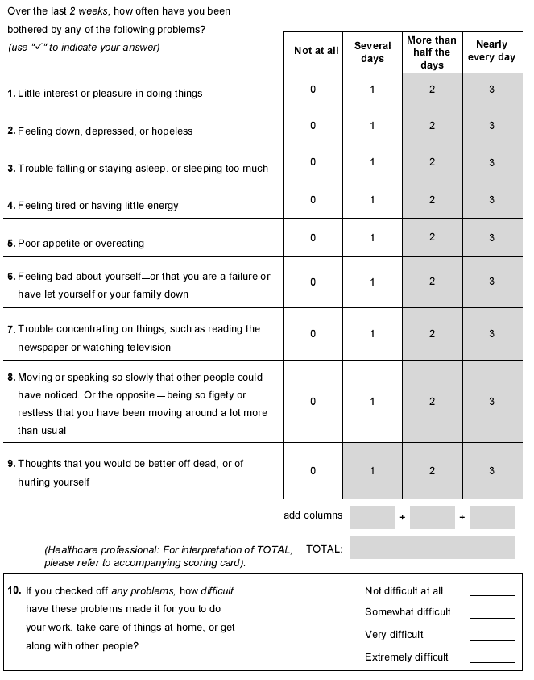
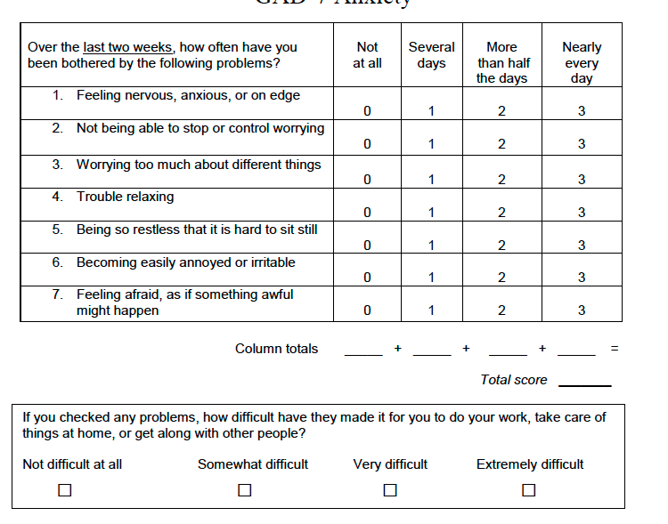

Lifestyle Management Survey – 10 questions
The following 2 scales are the Medication Adherence Report Scale (MARS-5) and the 5-Question Stigma Indicator - affected person

In this survey, we would like to explore your lifestyle habits, including your daily routines and health-related behaviours.

Medication Adherence Report Scale (MARS-5).
Item number | Question | Response
MARS-Q1 | I forget to take my anti-retroviral drugs | □ (1) Always  □ (2) Often  □ (3) Sometimes  □ (4) Rarely  □ (5) Never
MARS-Q2 | I alter the dose of my anti-retroviral drugs | □ (1) Always  □ (2) Often  □ (3) Sometimes  □ (4) Rarely  □ (5) Never
MARS-Q3 | I stop taking my anti-retroviral drugs for a while | □ (1) Always  □ (2) Often  □ (3) Sometimes  □ (4) Rarely  □ (5) Never
MARS-Q4 | I decide to skip a dose of my anti-retroviral drugs | □ (1) Always  □ (2) Often  □ (3) Sometimes  □ (4) Rarely  □ (5) Never
MARS-Q5 | I take less anti-retroviral drugs than instructed | □ (1) Always  □ (2) Often  □ (3) Sometimes  □ (4) Rarely  □ (5) Never

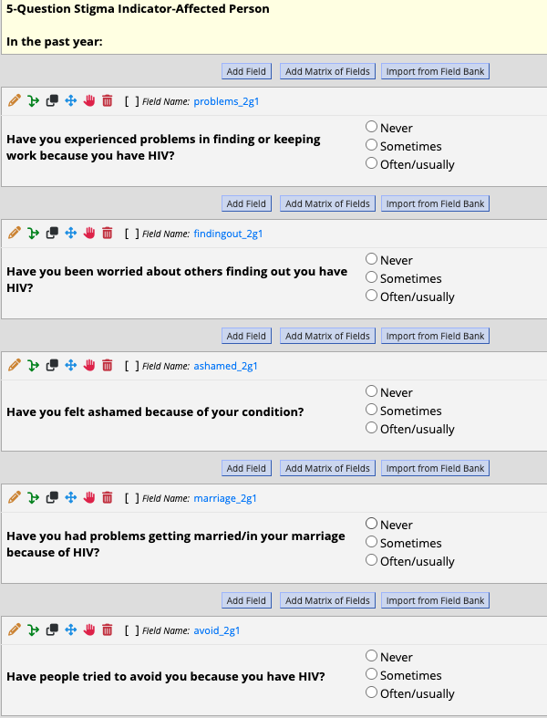

Personal Wellbeing Survey – 10 questions (Brief resilience scale and CAGE-AID)
The following 2 scales are the Brief Resilience Scale and the CAGE Questions adapted to include drug use.

In this survey, we would like to ask you about your personal wellbeing, including coping strategies and general psychological health.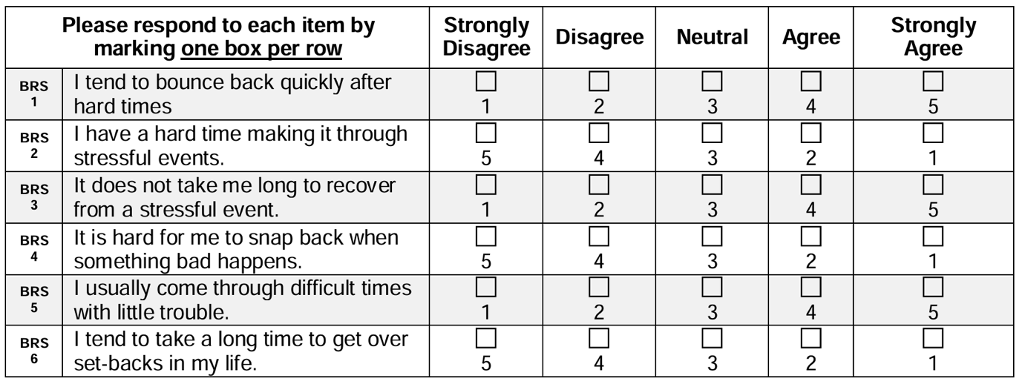

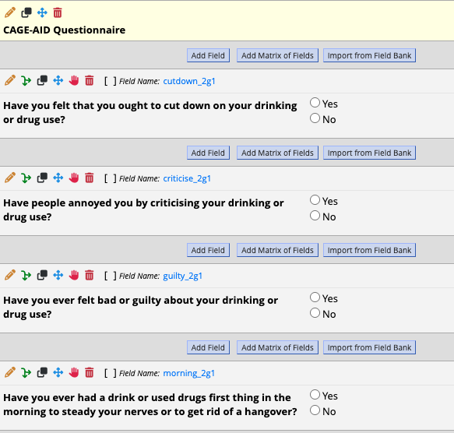

App Usability Scale – 18 questions
The following questionnaire is for the post-intervention groups only: the mHealth Usability Questionnaire.

In this survey, we would like to better understand what your experiences were of using the Moja Mind application.

